5th Frome Scout Group – Scavenger Hunt

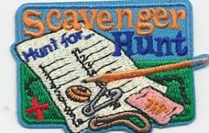

NAME.............................................................................
- F..........................................................

- R..........................................................

- O..........................................................

- M.........................................................

- E..........................................................

- S..........................................................

- C..........................................................

- O..........................................................

- U..........................................................

- T...........................................................

- S...........................................................

Total Score..........................

